Risk management plan – multiple hazards

Business name |  | Completed by
Business location |  | Date completed
Work area |  | Scheduled review date

Identify the hazard | Assess the risk | Control the risk

What is the hazard? | What might go wrong? Who might be harmed and how? | What are you already doing to control the risk? | Priority or risk level (low, med, high) * | What else do you need to do to control the risk? | Action by whom? | Action by when? | Date completed
Example:  Unguarded dough mixer | Bakers could accidently put hands in operating bowl and be cut or have finger amputated | Mixer in low traffic area. Procedures on safe use. | Medium | Install interlocking guard on mixer | J. Smith | 13/7/16 | 02/7/16

*The level of risk will increase as the likelihood of harm and its severity increases. For more details on the risk management process see page 2.

How to manage work health and safety risks
Use this information to help you complete the risk management table on the front of this form. This information is sourced from the How to manage work health and safety risks Code of Practice 2011. You can view the full code at worksafe.qld.gov.au.
Step 1
Identify hazards
Identify the things or situations that could potentially cause harm to people.
Step 4
Review controls
Reviews will help you identify if your controls become less effective.
Step 2  Assess hazards  Consider what could happen if someone is exposed to a hazard and how likely that is. |  |  | Step 3  Control hazards  Try to eliminate the risk first, or if that is not possible, put controls in place that minimise the risk so far as is reasonably practicable.
How to identify hazards  Try a number of ways, including:  - Inspecting the workplace  - Consulting workers, directly or through surveys, representatives, etc.  - Information from industry bodies, regulators and specialists, etc.  - Reading instruction manuals or safety data sheets  - Reviewing your records of incident reports, complaints, health monitoring, etc.  Where to look  Look in all aspects of work, including:  - the physical work environment  - equipment, materials and substances used  - work tasks and how they are performed  - work design and management (e.g. shift work) | Level of risk  Work out the level of risk by considering the possible severity injury and likelihood of it occurring.  The level of risk will increase as the likelihood and severity increase.  Severity  How severe could the harm be? Consider what type of injuries may happen, who it affects, if it could escalate, etc.  Likelihood  Work out the likelihood of harm occurring. You can estimate it by considering:  - How often is the task done? Does this make the harm more or less likely?  - How close do people get to the hazard?  - Has it ever happened before, either in your workplace or somewhere else? How often?  Consider if the harm is: certain to occur, very likely, possible, unlikely or rare. |  | Finding the best control  You can rank ways of controlling risks from the highest level of protection and reliability to the lowest. This ranking is known as the hierarchy of risk control (see below).  Always start at the most effective control (level 1, elimination), and work down the hierarchy. | Regular reviews  The control measures that you put in place should be reviewed regularly to make sure they work as planned. Don’t wait until something goes wrong.  If you find problems, go back through the risk management steps, review your information and make further decisions about risk control.
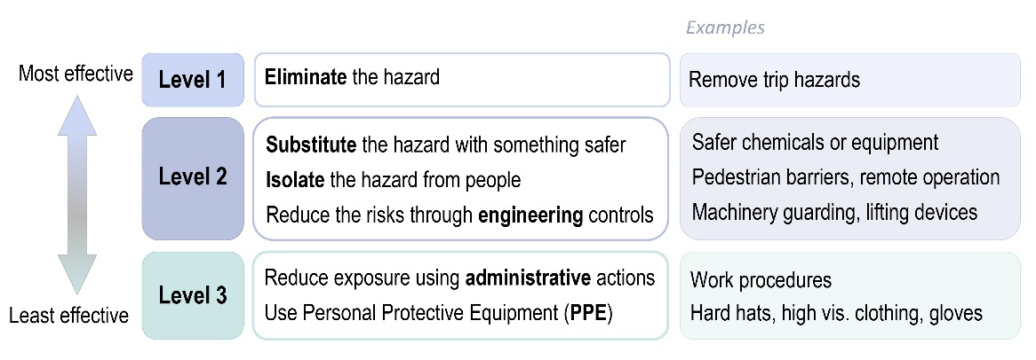
The hierarchy of risk control

